1. Created backend listner for IT Depot http request.

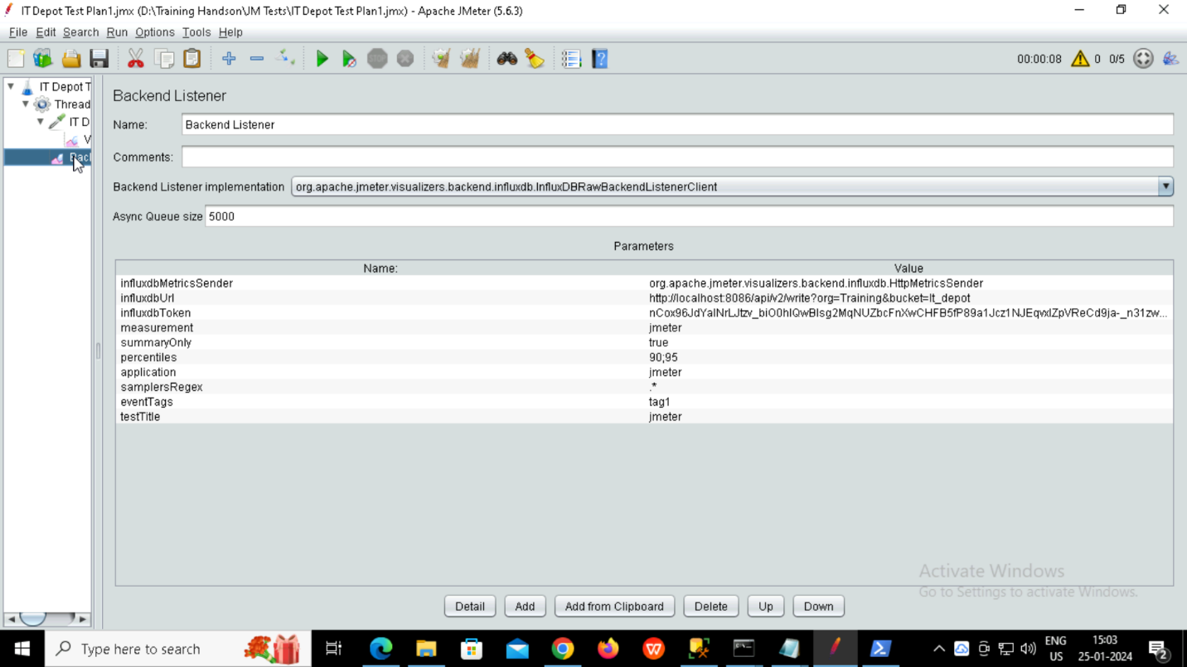

1. Created It_depot bucket and data explorerA screenshot of a computer

   Description automatically generated

3.Created data source in Grafana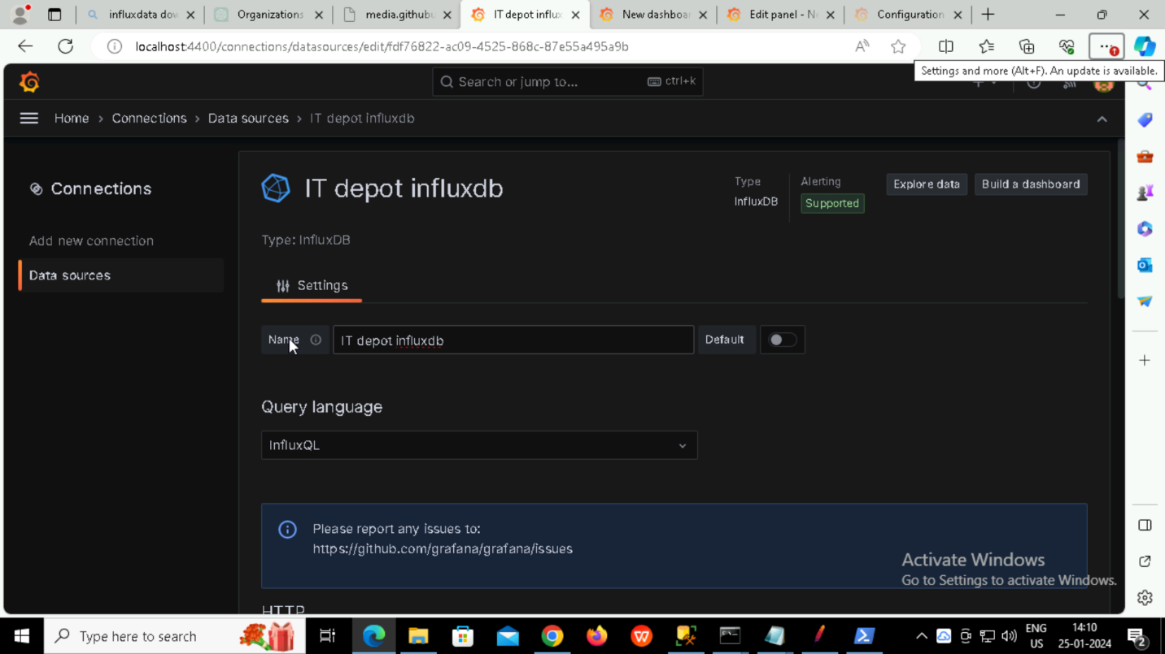

4. Created total 4 panels.3 panels that retrieve data from influxdb and one from csv file.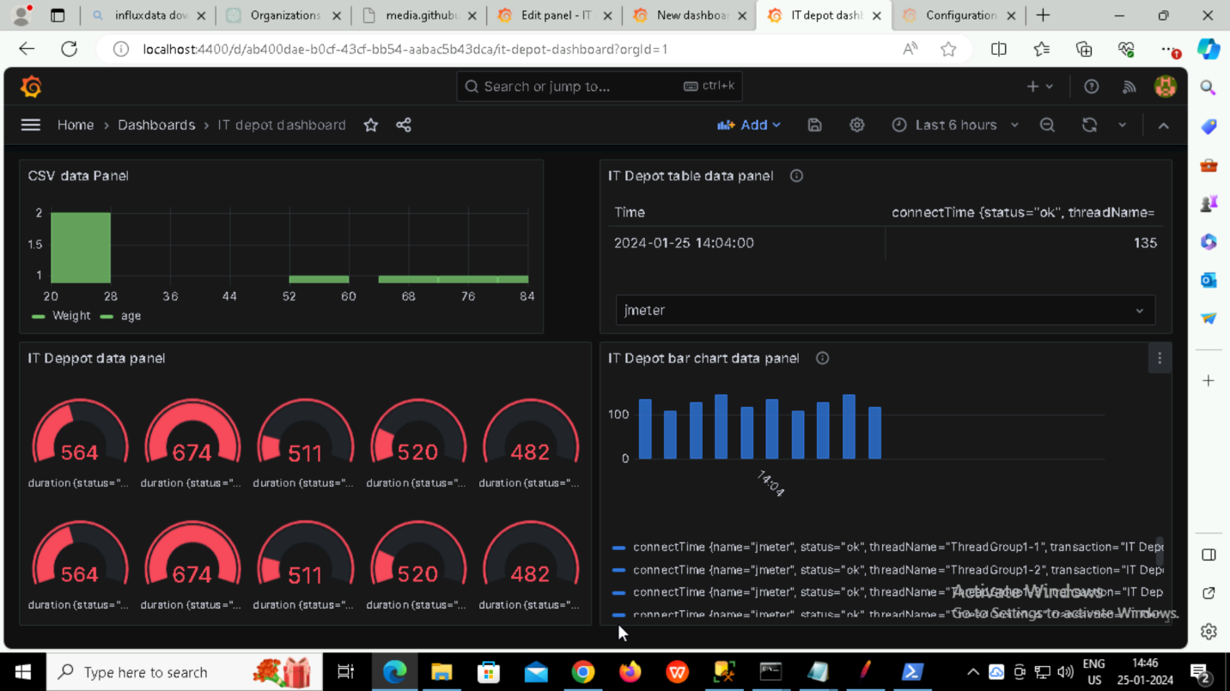

**Panel 1: Table**

Visualization Type: Table

Explanation: Showcase raw data with various columns like organization ID, name, location, and

**Panel 2: Bar Chart**

Visualization Type: Bar Chart

Explanation: Compare the number of employees in different organizations using a bar chart. Each bar represents an organization, and the height indicates the number of employees.

**Panel 3: Gauge**

Visualization Type: Gauge

Explanation: Use a gauge to represent a single metric, such as the average number of employees across all organizations. The gauge can show whether the metric is below, within, or above a target range.

5. Created Alerts

